**Metal**

**Time series plot for metal data set**

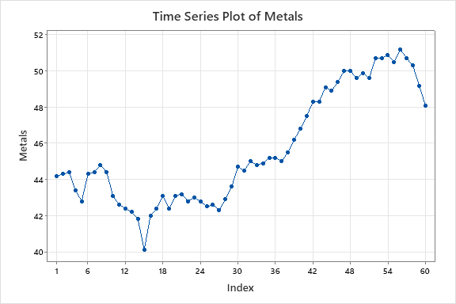

This plot exhibits some seasonal variation with an upward trend.

**Autocorrelation Function**

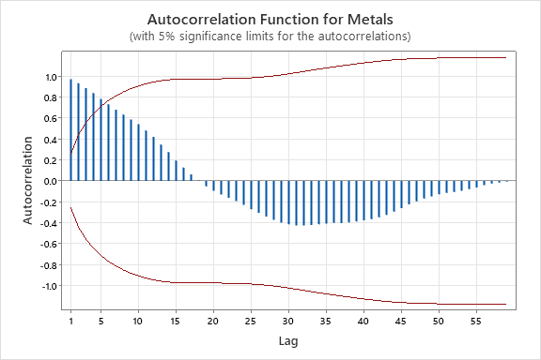

There is a slowly dice down pattern. Therefore, this is non-stationary.

Autocorrelations

Lag ACF T LBQ

1 0.970392 7.52 59.37

2 0.933986 4.26 115.32

3 0.886873 3.19 166.65

4 0.839069 2.61 213.42

5 0.783356 2.20 254.93

6 0.732309 1.91 291.87

7 0.679206 1.67 324.25

8 0.633619 1.49 352.97

9 0.587269 1.33 378.13

10 0.542342 1.20 400.01

11 0.481719 1.04 417.63

12 0.419593 0.89 431.27

13 0.345691 0.72 440.73

14 0.274724 0.57 446.83

15 0.195664 0.40 450.00

16 0.127019 0.26 451.36

17 0.061594 0.13 451.69

18 0.004952 0.01 451.69

19 -0.051848 -0.11 451.94

20 -0.094788 -0.19 452.77

21 -0.129680 -0.27 454.38

22 -0.160357 -0.33 456.89

23 -0.193426 -0.40 460.66

24 -0.228258 -0.47 466.04

25 -0.269864 -0.55 473.78

26 -0.304051 -0.61 483.90

27 -0.340393 -0.68 496.96

28 -0.370627 -0.74 512.93

29 -0.397793 -0.79 531.91

30 -0.412931 -0.81 553.06

31 -0.425365 -0.82 576.27

32 -0.425443 -0.81 600.31

33 -0.421402 -0.80 624.78

34 -0.413562 -0.77 649.25

35 -0.408188 -0.76 674.04

36 -0.401531 -0.74 699.04

37 -0.402472 -0.73 725.23

38 -0.394952 -0.71 751.61

39 -0.387151 -0.69 778.16

40 -0.376238 -0.67 804.49

41 -0.365507 -0.64 830.65

42 -0.346728 -0.61 855.49

43 -0.325035 -0.57 878.61

44 -0.292206 -0.51 898.46

45 -0.259998 -0.45 915.23

46 -0.222785 -0.38 928.42

47 -0.194503 -0.33 939.24

48 -0.168807 -0.29 948.07

49 -0.146598 -0.25 955.34

50 -0.126880 -0.22 961.33

51 -0.115048 -0.20 966.80

52 -0.104640 -0.18 971.89

53 -0.093207 -0.16 976.51

54 -0.077830 -0.13 980.27

55 -0.062038 -0.11 983.13

56 -0.040968 -0.07 984.69

57 -0.025385 -0.04 985.49

58 -0.014710 -0.03 985.89

59 -0.006185 -0.01 986.03

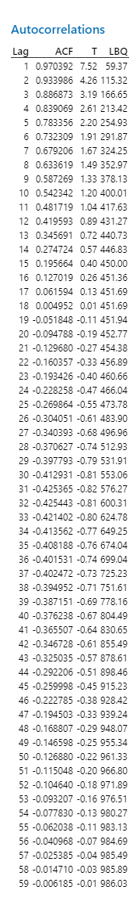

**Autocorrelation Function: Metal2**

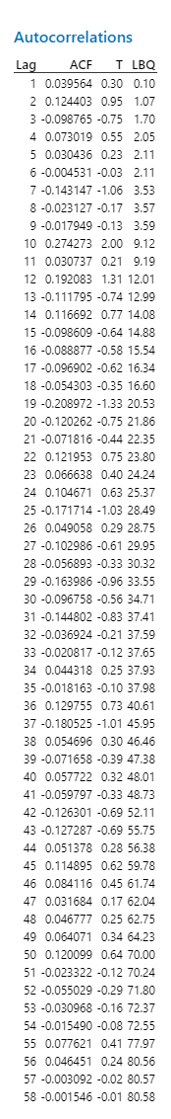

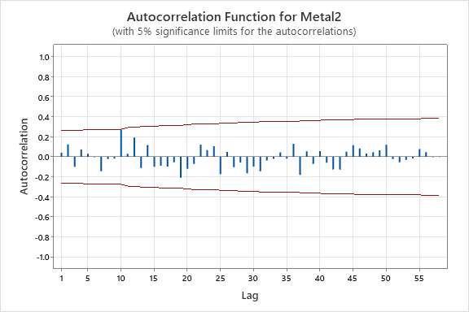

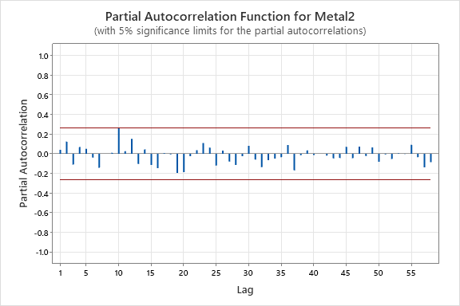**Partial Autocorrelation Function: Metal2**

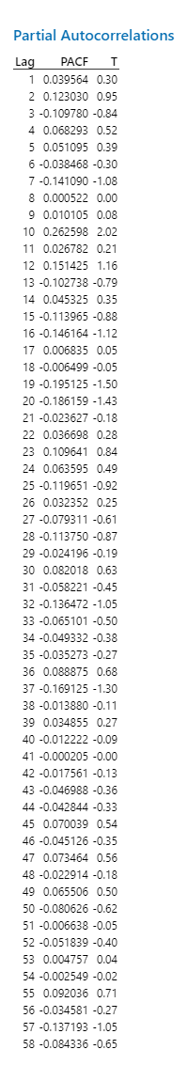

**Tentative Model**

p = 0 = cuts off at lag value in PACF in non-seasonal PACF

d = 1 = no of trend difference

q = 0 = cuts off lag value in ACF in non-seasonal

P = 0 = cuts off at lag value in PACF in seasonal

D = 0 = no of seasonal differences

Q = 0 = cuts off at lag value in ACF in seasonal

S = 0 = seasonal length

SARIMA (0,1,0) (0,0,0)

There are no any seasonal components.

Therefore, we can write this model as

ARIMA (0,1,0)